**Networking**

* [Home](https://www.techtarget.com/searchnetworking/)

* [Network infrastructure](https://www.techtarget.com/searchnetworking/resources/Network-Infrastructure)

**Definition**

# network interface card (NIC)

* [**TechTarget Contributor**](https://www.techtarget.com/contributor/TechTarget-Contributor)

## What is a network interface card (NIC)?

A network interface card (NIC) is a hardware component, typically a circuit board or chip, installed on a computer so it can connect to a network. Modern NICs provide functionality to computers, such as support for [input/output](https://www.techtarget.com/whatis/definition/input-output-I-O) interrupt, [direct-memory access](https://www.techtarget.com/whatis/definition/Direct-Memory-Access-DMA) interfaces, data transmission, network traffic engineering and partitioning.

A NIC provides a computer with a dedicated, full-time connection to a network. It implements the [physical layer](https://www.techtarget.com/searchnetworking/definition/physical-layer) circuitry necessary for communicating with a data link layer standard, such as Ethernet or Wi-Fi. Each card represents a device and can prepare, transmit and control the flow of data on the network.

The NIC uses the Open System Interconnection ([OSI](https://www.techtarget.com/searchnetworking/definition/OSI)) model to send signals at the physical layer, transmit data packets at the network layer and operate as an interface at the [TCP/IP](https://www.techtarget.com/searchnetworking/definition/TCP-IP) layer.

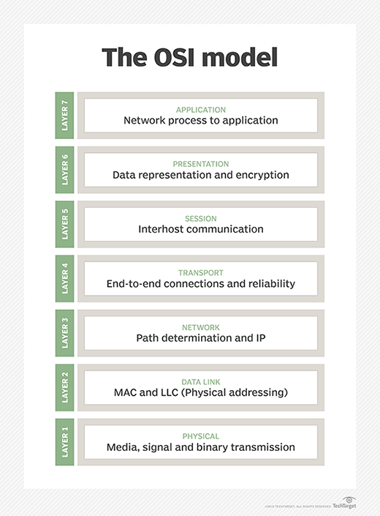The NIC performs different functions for different layers of the OSI model.

The NIC operates as a middleman between a computer and a data network. For example, when a user requests a webpage, the computer passes the request to the network card, which converts it into electrical impulses.

A web server on the internet receives the impulses and responds by sending the webpage back to the network card as electrical signals. The card receives these signals and translates them into the data that the computer displays.

Network controllers were originally implemented as expansion cards that could plug into a computer port, router or USB device. However, more modern controllers are built directly into the computer motherboard chipset. Users can purchase expansion card NICs online or in retail stores if they need additional independent network connections. When users [choose a NIC](https://www.cablesandkits.com/learning-center/how-to-choose-a-network-card), its specifications should correspond with the standard of the network.

The term network interface card is often interchangeable with the terms network interface controller, network adapter and [LAN](https://www.techtarget.com/searchnetworking/definition/local-area-network-LAN) adapter.

## Types of NICs

While the standard NIC is a plastic circuit board that slides into a computer to connect with the motherboard, this connection can occur in multiple ways. Some types of NICs include the following:

* **Wireless.** NICs that use an antenna to provide wireless reception through [radio frequency](https://www.techtarget.com/searchnetworking/definition/radio-frequency) waves. Wi-Fi connections use wireless NICs.
* **Wired.**  NICs that have input jacks made for cables. Ethernet is the most popular wired LAN technology.
* **USB.** NICs that provide network connections through a device plugged into the USB port.
* **Fiber optics.** NICs used as a high-speed support system for network traffic handling on server computers. It's also possible to achieve this support by combining multiple NICs. Fiber optic NICs are typically more expensive and complex.

## NIC components

Components of NICs include the following:

* **Speed.** All NICs have a speed rating in terms of megabits per second (Mbps) that determines the card's performance in a network. If the network's bandwidth is lower than the NIC or multiple computers connect with the same controller, the labeled speed decreases. The average Ethernet NICs come in 10 Mbps, 100 Mbps, 1000 Mbps and 1 gigabits per second varieties.
* **Driver.** The required software that passes data between the computer's [operating system](https://www.techtarget.com/whatis/definition/operating-system-OS) and the NIC. When a NIC is installed on a computer, the corresponding driver software is also downloaded. Drivers must stay updated and uncorrupted to ensure optimal performance from the NIC.
* **MAC address.** Unique, unchangeable [media access control addresses](https://www.techtarget.com/searchnetworking/definition/MAC-address), also known as physical network addresses, are assigned to NICs. MAC addresses deliver Ethernet packets to the computer.
* **LED indicator.** Most NICs have an LED indicator integrated into the connector to notify the user when the network connects and data transmission occurs.
* **Router.** A router is sometimes needed to enable communication between a computer and other devices. In this case, the NIC connects to the router which is connected to the internet.